**Lab no: 1 – SIMPLE C PROGRAMS**

Q1. Write a C program to add two integers a and b read through the keyboard. Display the result using third variable sum.

**Program:**

/* Computing the sum of two numbers */

#include <stdio.h>

#include <stdlib.h>

int main()

{

printf("Name : MANOJ M MALLYA\n\n");

int a,b,sum;

printf("Enter two integers : ");

scanf("%d %d",&a,&b);

sum = (a+b); // sum

printf("\nThe sum of %d and %d is %d\n",a,b,sum);

return 0;

}

**Output:**

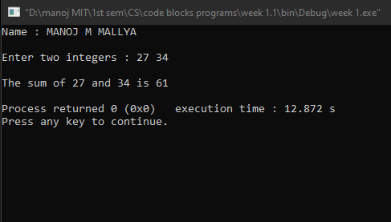

Q2. Write a C program to find the sum, difference, product and quotient of 2 numbers.

**Program:**

/* Finding the sum, difference, product and quotient of 2 numbers */

#include <stdio.h>

#include <stdlib.h>

int main()

{

printf("Name : MANOJ M MALLYA\n\n");

double a,b;

double sum,difference,product,quotient;

printf("Enter the first number : ");

scanf("%lf",&a);

printf("Enter the second number (non-zero number) : ");

scanf("%lf",&b);

sum = a + b;

difference = a - b;

product = a * b;

quotient = a / b ;

printf("\nSum = %lf \nDifference = %lf \nProduct = %lf \nQuotient = %lf\n",sum,difference,product,quotient);

return 0;

}

**Output:**

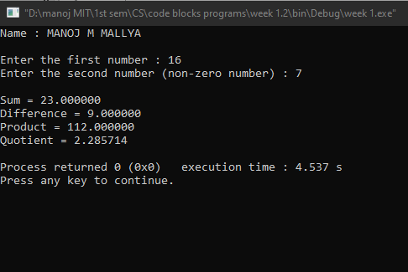

Q3. Write a C program to print the ASCII value of a character.

**Program:**

/* Printing the ASCII value of a character */

#include <stdio.h>

#include <stdlib.h>

int main()

{

printf("Name : MANOJ M MALLYA\n\n");

char letter;

printf("Enter the character : ");

scanf("%c",&letter);

printf("\nThe ASCII value of %c is %d\n",letter,letter);

return 0;

}

**Output:**

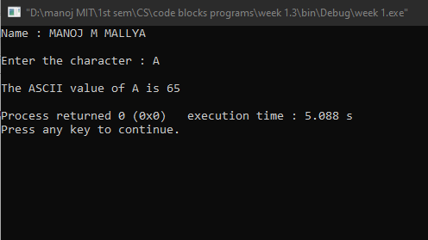

Q4. Write a C program to display the size of the data type int, char, float, double, long int and long double using size of ( ) operator.

**Program:**

/* Getting the size of different data types */

#include <stdio.h>

#include <stdlib.h>

int main()

{

printf("Name : MANOJ M MALLYA\n\n");

printf("size of int = %d bytes\n",sizeof(int));

printf("size of char = %d bytes\n",sizeof(char));

printf("size of float = %d bytes\n",sizeof(float));

printf("size of double = %d bytes\n",sizeof(double));

printf("size of long int = %d bytes\n",sizeof(long int));

printf("size of long double = %d bytes\n",sizeof(long double));

return 0;

}

**Output:**

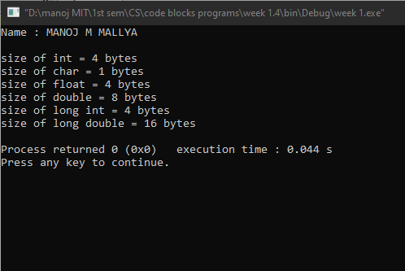

Q5. Input P, N and R to compute simple and compound interest. [Hint: SI = PNR/100, CI = P(1+R/100)N -P]

**Program:**

/* computing simple and compound interest */

#include <stdio.h>

#include <stdlib.h>

#include <math.h>

int main()

{

printf("Name : MANOJ M MALLYA\n\n");

double principal,time,rate,simple_interest,compound_interest;

printf("Enter principal amount(in Rs) : ");

scanf("%lf",&principal);

printf("Enter the term period(in years) : ");

scanf("%lf",&time);

printf("Enter the rate of interest(in percentage) : ");

scanf("%lf",&rate);

// computation

simple_interest = (principal*time*rate)/100;

compound_interest = principal*pow((1+rate/100),time) - principal;

printf("Simple interest = %lf \nCompound interest = %lf ",simple_interest,compound_interest);

return 0;

}

**Output:**

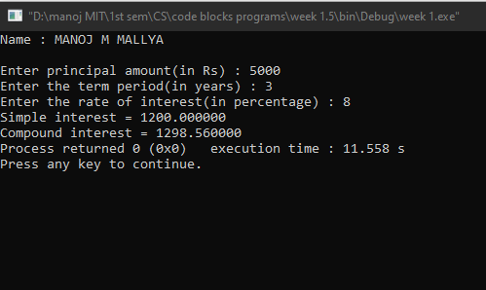

Q6. Input radius to find the volume and surface area of a sphere. [Hint: volume = (4πr3 )/3, Area=4πr2 ]

**Program:**

/* Finding volume and surface area of a sphere */

#include <stdio.h>

#include <stdlib.h>

#define PI 3.14159265 //defining the value of irrational constant π (pi)

int main()

{

printf("Name : MANOJ M MALLYA\n\n");

double radius,volume,surface_area;

printf("Enter the radius of sphere : ");

scanf("%lf",&radius);

//computation

volume = (4*PI*radius*radius*radius)/3;

surface_area = 4*PI*radius*radius;

printf("\nThe volume of the sphere is %lf\n",volume);

printf("\nThe surface area of the sphere is %lf\n",surface_area);

return 0;

}

**Output:**

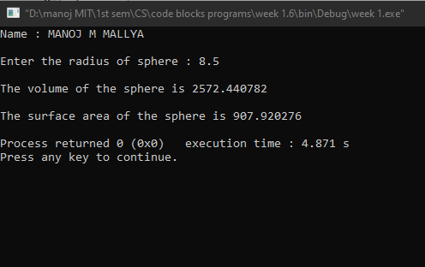

Q7. Convert the given temperature in Fahrenheit to Centigrade. [Hint: C=5/9(F-32)]

**Program:**

/* Conversion from Fahrenheit to Centigrade */

#include <stdio.h>

#include <stdlib.h>

int main()

{

printf("Name : MANOJ M MALLYA\n\n");

float fahrenheit,centigrade;

printf("Enter the temperature in Fahrenheit : ");

scanf("%f",&fahrenheit);

//conversion

centigrade = 5*(fahrenheit-32)/9;

printf("\nThe temperature in Centigrade = %f ",centigrade);

return 0;

}

**Output:**

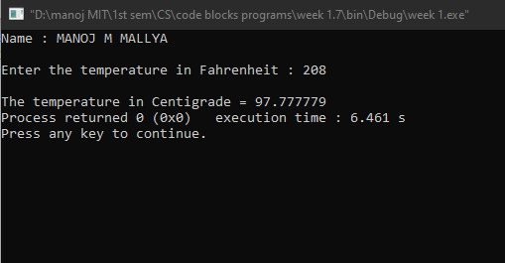

Q8. Write a C program to evaluate the following expression for the values a = 30, b=10, c=5, d=15. (i ) (a + b) * c / d (ii) ((a + b) * c) / d (iii) a + (b * c) / d (iv) (a + b) * (c / d)

**Program:**

/* Evaluation */

#include <stdio.h>

#include <stdlib.h>

int main()

{

printf("Name : MANOJ M MALLYA\n\n");

int a=30,b=10,c=5,d=15;

printf("(a + b) * c / d = %d \n((a + b) * c ) / d = %d \na + (b * c) / d = %d \n(a + b) * (c / d) = %d\n",(a + b)*c/d, ((a + b)*c)/d, a+ (b*c)/d, (a + b)*(c/d));

return 0;

}

**Output:**

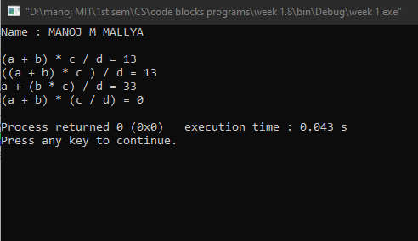

**********

**Lab no: 2 – BRANCHING CONTROLSTRUCTURES**

Write C programs to do the following:

Q1. Check whether the given number is odd or even.

**Program:**

/* checking whether a number is odd or even */

#include <stdio.h>

#include <stdlib.h>

int main()

{

printf("Name : MANOJ M MALLYA\n\n");

int n;

printf("Enter a number : ");

scanf("%d",&n);

//checking remainder when divided by 2

if (n%2==1)

{

printf("\n%d is an odd number.\n",n);

}

else

{

printf("\n%d is an even number.\n",n);

}

return 0;

}

**Output:**

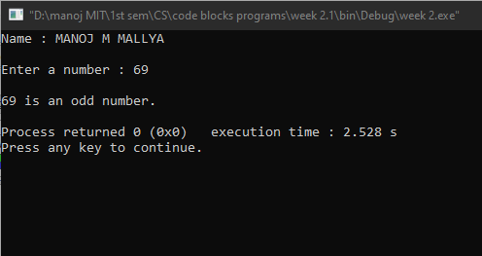

Q2. Find the largest among given 3 numbers.

**Program:**

/* finding the largest number */

#include <stdio.h>

#include <stdlib.h>

int main()

{

printf("Name : MANOJ M MALLYA\n\n");

int a,b,c;

printf("Enter 3 numbers : ");

scanf("%d %d %d",&a,&b,&c);

if (a>b)

{

if (a>c)

{

printf("\n%d is the largest number.\n",a);

}

else

{

printf("\n%d is the largest number.\n",c);

}

}

else

{

if (b>c)

{

printf("\n%d is the largest number.\n",b);

}

else

{

printf("\n%d is the largest number.\n",c);

}

}

return 0;

}

**Output:**

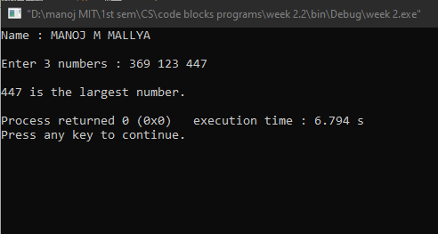

Q3. Swap two numbers without using third variable.

**Program:**

/* swapping two numbers witjout using 3rd variable */

#include <stdio.h>

#include <stdlib.h>

int main()

{

printf("Name : MANOJ M MALLYA\n\n");

int a,b;

printf("Enter first number : ");

scanf("%d",&a);

printf("\nEnter second number : ");

scanf("%d",&b);

a=a+b;// a becomes (a+b)

b=a-b;//b becomes a

a=a-b;//a becomes b

printf("\nFirst number after interchanging : %d\n",a);

printf("\nSecond number after interchanging : %d\n",b);

return 0;

}

**Output:**

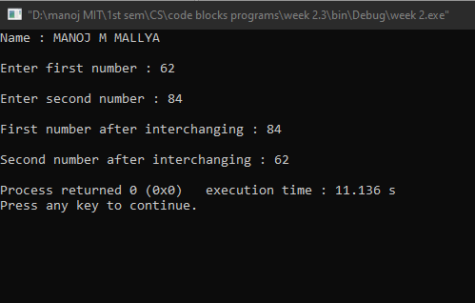

Q4. Compute all the roots of a quadratic equation using switch case statement. [Hint: x = (-b +/- sqrt(b2 -4ac))/2a]

**Program:**

/* getting the roots of a quadratic equation */

#include <stdio.h>

#include <stdlib.h>

#include <math.h>

int main()

{

printf("Name : MANOJ M MALLYA\n\n");

double a,b,c,x,y,real,imaginary;

printf("The quadratic equation is of the form ax^2+bx+c=0\n\n");// standard form of a quadratic equation

printf("Enter a : ");

scanf("%lf",&a);

printf("Enter b : ");

scanf("%lf",&b);

printf("Enter c : ");

scanf("%lf",&c);

double disc = (b*b)-(4*a*c);//disc - discriminant

int k;

if(a!=0)

{

if (disc > 0)

{

k=1;

}

if (disc == 0)

{

k=2;

}

if (disc < 0)

{

k=3;

}

switch (k)

{

case 1:

printf("\nRoots are real and distinct.\n");

x = ((-b) + sqrt((b*b) - (4*a*c)))/(2*a);//1st root

y = ((-b) - sqrt((b*b) - (4*a*c)))/(2*a);//2nd root

printf("\nThe two roots of the quadratic equation are x = %lf and y = %lf\n",x,y);

break;

case 2:

printf("\nRoots are real & equal.\n");

x = -b / (2*a);

printf("\nThe two roots of the quadratic equation are %lf and %lf\n",x,x);

break;

case 3:

printf("\nRoots are imaginary.\n");

real = -b / (2*a) ;

imaginary = (sqrt (-1*disc)) / (2*a);

printf("\nThe two roots of the quadratic equation are x = %f + i(%f) and y = %f - i(%f)\n",real,imaginary,real,imaginary);

}

}

else

{

printf("\nIts a linear equation.\n");// as the co-efficient of 'a' is zero.

}

return 0;

}

**Output:**

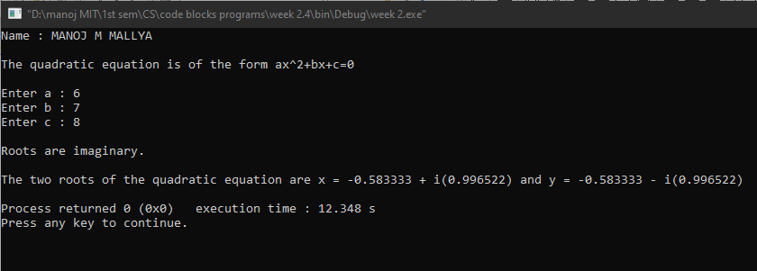

Q5. Write a program that will read the value of x and evaluate the following function

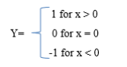

Use else if statements & Print the result (‘Y’ value).

**Program:**

/* signum function */

#include <stdio.h>

#include <stdlib.h>

int main()

{

printf("Name : MANOJ M MALLYA\n\n");

int n,result;

printf("Enter a number : ");

scanf("%d",&n);

if (n>0)

{

result = 1;//when the number is greater than zero

}

else if (n<0)

{

result = -1;//when the number is less than zero

}

else

{

result = 0;//when the number is equal to zero

}

printf("\nThe result of the function = %d\n",result);

return 0;

}

**Output:**

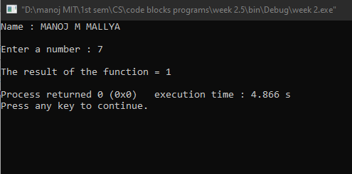

Q6. Find the smallest among three numbers using conditional operator.

**Program:**

/* finding the smallest of 3 numbers using conditional operator */

#include <stdio.h>

#include <stdlib.h>

int main()

{

printf("Name : MANOJ M MALLYA\n\n");

int a,b,c,small;

printf("Enter three numbers : ");//getting the 3 numbers

scanf("%d %d %d",&a,&b,&c);

small = (a < b)? ((a < c)? a : c ) : ((b < c)? b : c);//getting the smallest number

printf("\nThe smallest number is %d\n",small);//printing the smallest number

return 0;

}

**Output:**



